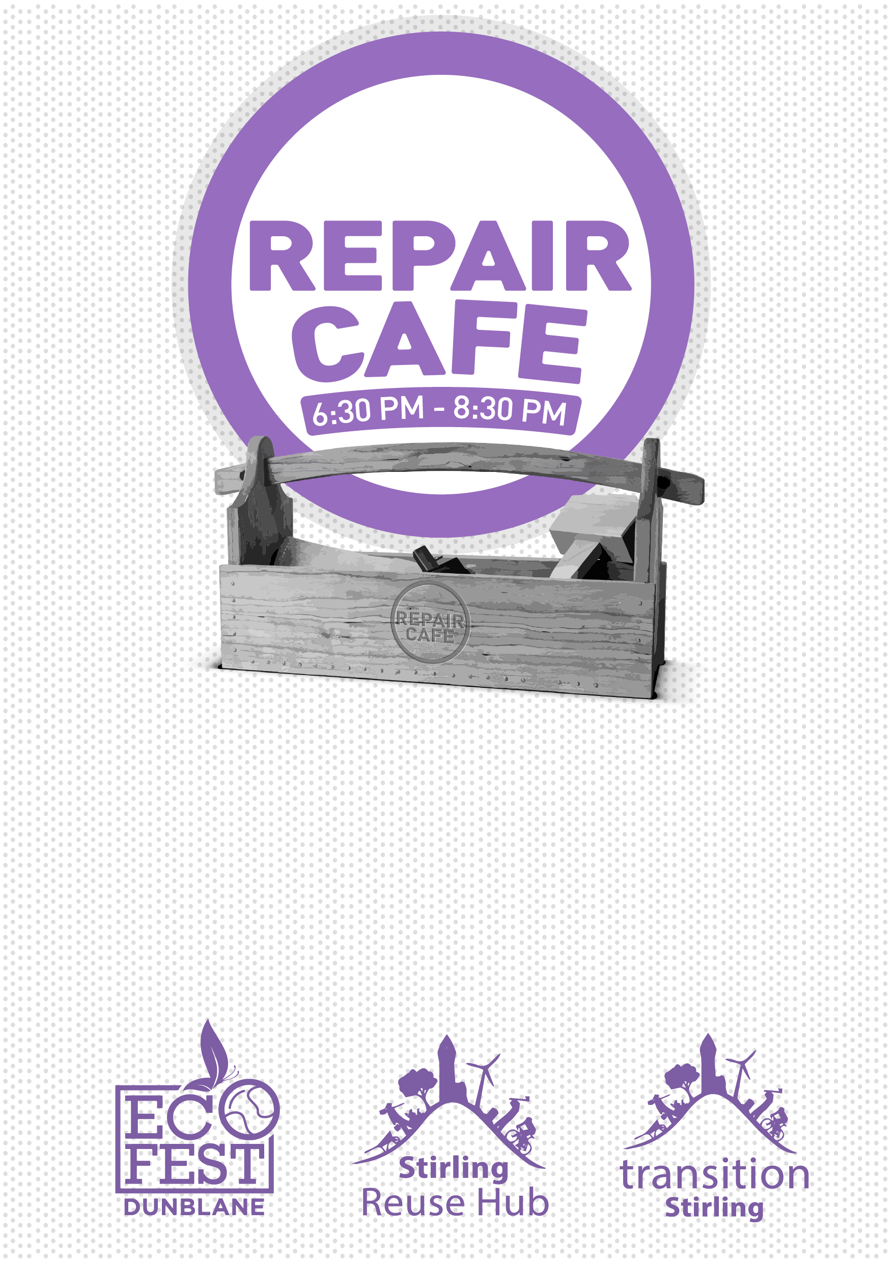

Tuesday

1st September

ST MARY’S CHURCH HALL
DUNBLANE

Do you have something

that can be repaired?

Bring it to the REPAIR CAFE,
St Mary’s Church Hall, Dunblane
on Tuesday 1st September
SMALL ELECTRICALS, TEXTILES, WOOD, TOOLS,
TOOL SHARPENING ETC
(Our repairers will do their best to repair all sorts)

Caption

