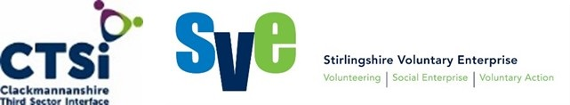

Clackmannanshire and Stirling Health and Social Care Partnership
Ideas, Innovation, Improvement Fund
Application Guidance Notes

The Clackmannanshire and Stirling Health and Social Care Partnership have allocated money from the Integrated Care Fund (ICF) for one–off grants to support the development of new or existing third sector initiatives which build capacity within communities in order to encourage health and wellbeing. This money is being administered by SVE and CTSi through the Ideas, Innovation, Improvement (I.I.I.) Fund.
Applications for the Ideas, Innovation, Improvement Fund are invited from constituted groups and organisations to support initiatives which meet the following criteria:

Applications must:
Be from third sector (voluntary) organisations - Third Sector organisations include community groups, voluntary organisations, charities or social enterprises; these groups must have a constitution.

Support the Clackmannanshire and Stirling Health and Social Care Partnership to deliver integrated or joined up health and social care services – The money for this fund comes from the Clackmannanshire and Stirling Health and Social Care Partnership therefore activities need to support the vision of people living full and positive lives within supportive communities. The links below and Appendix 1 provide more details about the strategy and priorities that underpin this vision.

Strategic Plan:
https://nhsforthvalley.com/wp-content/uploads/2015/11/Strategic-Plan.pdf

Strategic Plan - Easy Read Version:
https://nhsforthvalley.com/wp-content/uploads/2015/11/Strategic-Plan-Easy-Read-Version-2016-2019.pdf

Demonstrate sustainability – Applications must demonstrate how the impact or increased capacity generated with money from the fund will be sustained once the funding period comes to an end.

Scope of the Fund

The fund aims to award grants to community based activities that support adults to maintain or improve their health and wellbeing. The fund also seeks to fund activities that increase the ability of community based organisations to provide a service to local people. Communities may be geographical or communities of interest.

Awards

Applications for amounts up to a maximum of £2,000 for an individual organisation or up to £6,000 for organisations applying in partnership will be considered. Partnership applications must clearly demonstrate the benefit of the partnership approach.

Applications should describe the outcomes they want to achieve and explain how these fit with the Partnership vision of people living full and positive lives within supportive communities. Applications should show how the impact of the money from the I.I.I. Fund will be sustained following the period of funding. Grants will be awarded to applications that are innovative, either in terms of developing an existing activity or starting a new activity. The grant is not able to cover core costs. Applications should also demonstrate why there is a need for the proposed activity and how it fits with any other, similar activities or organisations in order to prevent duplication.
While the fund will not cover core costs, where the application demonstrates that there is a need and a clear link to the proposed outcomes the fund will consider cover the costs of resources required for a new initiative. These resources will generally be physical assets that will exist with the group after the funding period has ended, for example. Some groups may need to have training or cover volunteer and sessional worker costs as part of their sustainability planning. These costs will be considered if organisations can show that the project will continue to have an impact after the funding ends.
Grants will be split 40 / 60 between Clackmannanshire and Stirling to reflect different population size.
The Small Grant Fund is a non-recurring grant and as such successful recipients should not expect to be able to apply to the fund again in the future for the same activity.

Funding will be considered for:

Improvements in practice.

This may involve training to increase knowledge and skills in order to deliver best practice.

Improvements in outcomes for service users.

These could include testing new activities within your organisation or testing the impact of changes to existing activities.

We are not able to fund:

- Projects that are solely aimed at children under 18.

- Items that only benefit an individual – for example, scholarships and personal clothing for individuals and equipment that is not shared.

- Payments to individuals

- Fundraising events

- Any goods or services that you buy or order before we confirm our grant.

- Activities promoting religious or political beliefs.

- Projects where the people who benefit live outside of the Stirling or Clackmannanshire Council areas.

- Routine repair and maintenance costs.

- Endowments, loan payments, bank interest charges.

- Activities or projects already funded by the Integrated Care Fund.

- Activities that already receive funding, however this grant can be used to build on, compliment or develop existing activities that receive some funding from elsewhere.

Please note the above list is not exhaustive.

Monitoring and Evaluation
Successful grant recipients will be expected to monitor and report on how the grant has been spent and the impact that it has had using the format provided by SVE and CTSi. Reporting and monitoring will be proportionate to the amount of money received and SVE and CTSi will be available to provide support. Projects are encouraged to measure small tests of change using the Plan Do Study Act (PDSA) methodology.

The Plan, Do, Study Act model provides a useful structure for developing and evaluating initiatives.
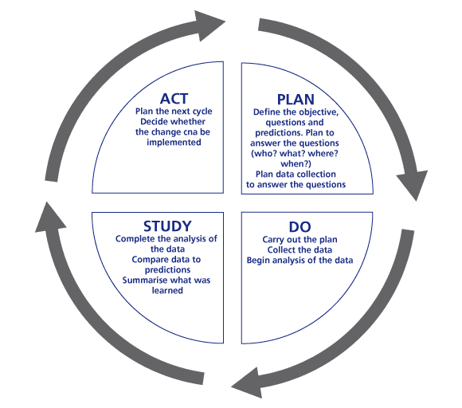
Plan Do Study Act allows you to try out an idea by testing small changes.
Plan
- What is the problem you are trying to solve? What change would you like to test? What do you think will happen? How will you record any changes?

Do
- Carry out the test and record what happens.
Study
- Look at the results. Compare what happened to what you predicted.
Act
- Looking at what you have learned plan the next cycle or implementation.

Case Study
The case study is intended to give additional information and ideas and is in no way prescriptive.
Healthy Eating Group
An existing community group would like to expand the activities it is able to offer and make better use of the facilities in the community centre by forming a healthy eating group. The group aims to bring people together to plan, cook and eat a health meal on a budget, with the additional benefits of reducing the social isolation and increasing the confidence of participants. Funding is requested to buy cooking equipment (e.g. pans, weighing scales and cooking implements), for a session tutor to facilitate the sessions and also money to print a cookbook at the end of the sessions. The session tutor will be asked to give the group the basic skills in planning, shopping and cooking on a budget so that the group will be able to continue independently once the facilitated sessions have finished.

How to Apply

- Please complete the attached application form. The application form has two sections – an overview of proposed activities and a breakdown of costs. Please complete both sections and submit, with a copy of your organisation’s most up to date Annual Accounts and a copy of your constitution to:

Liz Rowlett
Email – Liz.rowlett@ctsi.org.uk
Or
Hard copy to Clackmannanshire Third Sector Interface
Glebe Hall, Burgh Mews, Alloa FK10 1HS

Closing Date: 25th May 2018

If you have any queries or would like to discuss your proposal please contact:
Liz Rowlett – Liz.rowlett@ctsi.org.uk Tel: 01259 213840

Appendix 1
Clackmannanshire and Stirling Health and Social Care Partnership

Vision
To enable people in the Clackmannanshire and Stirling Health and Social Care Partnership area to live full and positive lives within supportive communities.

Outcomes
Self-Management - People are able to look after their health, care and wellbeing.
Community Supports - People can live well at home or in a home they like in their community, for as long as possible.
Safety - People are safe and live well for longer.
Decision Making - People make choices about their care.
Experience – Individuals will have a fair and positive experience of health and social care.

Key Themes
Early Intervention and Prevention
Service users are supported to self manage
Service Users exercise choice and control
Staff are skilled and supported to deliver person centred care
Carers are recognised and valued as equal partners in the delivery of care
Focus on rehabilitation, recovery and reablement, leading to fewer avoidable admissions and discharge planning is effective and efficient.
Services work together with communities to improve access to services and build capacity; this reduces health inequalities within and across our communities.

Priorities
Make sure that front line staff can easily find out and share information across professions and organisations
Support more co-location of staff from across professions and organisations
Develop single care pathways which recognise that there are many more conditions than services available
Further develop anticipatory and planned care services for people with multiple long term conditions
Provide more single points of entry to services where named care coordinators help people receive more holistic services
Develop seven-day access to appropriate services to maximise quality of care
Open the Stirling Care Village.
Spend money on what works well.
Help unpaid carers to stay healthy and feel supported so that they can continue to provide care.
Try to help people stay healthy and well at home so that they only go into hospital when they need to.
Ideas, Innovation and Improvement Fund
Application Form
Section One
Is the proposal being made on behalf of a partnership? | Yes
Is the proposal being made on behalf of a partnership? | No
Is the proposal being made on behalf of a partnership? | If yes, please give details of partners below, if no, please give details of your organisation:
Name of Organisation |  |  | Registered Charity Number
1.

2.

3.

Contact Information
Contact information should be for the person who will have operational responsibility for the project and who we should contact about the form.
Contact Name

Contact Phone Number

Contact Email Address

Contact Postal Address

Project Outline
Please give an overview of the main aims and objectives of each the organisations involved in this project. (This may be just one organisation or more for a partnership application.)

Please provide a brief overview of the proposed project.

Please outline the roles that each organisation will play in this project.

Who are you planning to reach?

How do you know that there is a need for this project?

Is anyone else doing a similar project and where does your organisation or project fit in?

Resources
What resources do you already have that will contribute to this project?

What additional resources do you need?

Anticipated Outcomes
How will your project support people to be better able to maintain or regain their health and / or wellbeing?

What changes do you expect to see as a result of your activities?

How will you gather this information?

How will you know if a change is an improvement?

Sustainability
How will change and improvement be maintained after the grant has been spent?

Ideas, Innovation and Improvement Fund
Section 2
Please provide a breakdown of how the grant would be used.
These headings are intended to help you structure your budget. Please feel free to delete or add lines and appropriate headings as required.

Name of Organisation
STAFF/VOLUNTEER COSTS  (travel, training, sessional work costs etc.) | ANTICIPATED SPEND
 | £
 | £
 | £

PROPERTY/VENUE COSTS

(rent, hire, insurance, etc)
 | £
 | £
 | £

SUPPLIES & SERVICES

(resources, equipment, publicity, hospitality etc)
 | £
 | £
 | £

OTHER COSTS PLEASE SPECIFY

(events, community engagement, research and evaluation)
 | £
 | £
 | £
TOTAL | £
Project lead | Signature

